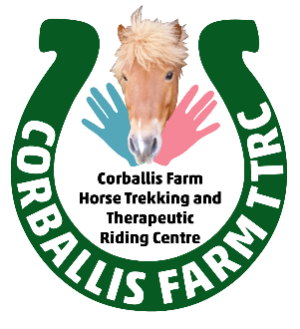
CORBALLIS FARM HORSE TREKKING AND THERAPEUTIC RIDING CENTRE:
NEW WEEKLY LESSON AND TREKKING TIMES FROM SEPTEMBER 2016
TUESDAYS: 10:00AM TO 12.00PM - ADULT EQUINE COURSE
3.15PM - 4.15PM : BEGINNER / INTERM LESSON/TREK
4.30PM - 5.30PM : ADVANCED LESSON/TREK
WEDNESDAYS: 9.30AM / 10.45AM / 12PM : GROUP LESSONS /TREKS
4PM TO 6PM : STABLE CLUB : FOR HORSE MAD CHILDREN AND TEENS! RIDING / STABLE MANAGEMENT / TEAM BUILDING
THURSDAYS: 9AM / 10AM : GROUP LESSONS/ TREKS
11AM: ADULT BEGINNER/INTERMEDIATE LESSON
3.15PM- 4.15PM: BEGINNER / INTERM LESSON
4.30PM - 5.30PM: ADVANCED LESSON/TREK
FRIDAYS: 10:00AM TO 12.00PM – ADULT EQUINE COURSE
3.15PM – 4.15PM: BEGINNER/ INTERM LESSON/TREK
4.30PM – 5.30PM: ADVANCED LESSON/TREK
SATURDAYS: 9.30AM – 10.30AM : ADVANCED LESSON/TREK
10.45AM- 11.45AM: INTERMEDIATE LESSON/ TREK
12PM – 1PM: BEGINNER LESSON/ TREK
2PM – 3PM : BEGINNER/INTERM LESSON/TREK
3.15PM- 4.15PM: ADVANCED TREK
SUNDAYS: TREKKING ONLY EVERY 2ND SUNDAY 11AM / 12.30PM
Please note booking is subject to availability as there are limited spaces per class.

